WATER SUPPLY, IRRIGATION AND DRAINAGE
Sources of water
- Surface water
- underground water
- Rain water
1. Surface water
Sources of surface water are:
- Rivers
- Streams
- Lakes
2. Ground water
Sources of ground water are:
- Springs
- Wells
- Boreholes
a) Springs
- Here water comes out of the ground as a result of an impervious layer meeting the ground surface.
- Low wall can be constructed around the spring to increase the water volume for easier pumping
- Also on higher ground, water can be conveyed to lower grounds by gravitational flaw
Diagram of a spring
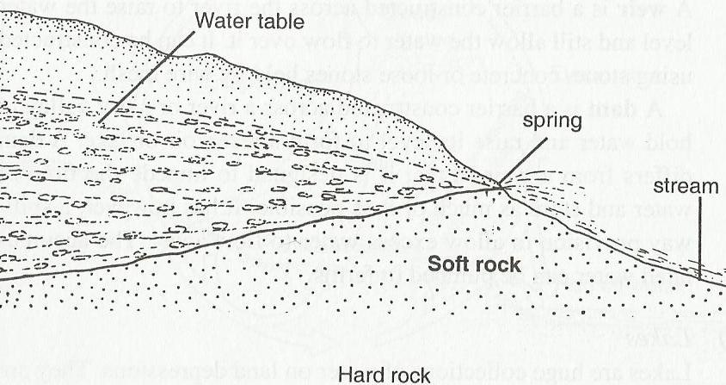
b) Wells
- Wells are holes dug in the ground until water table is reached. Can go up to 15m deep.
- It’s advisable to dig the well during dry season to ensure that even during dry season water will be available
- Fence around the well to avoid contamination
- Construct a reinforced slab with a lockable lid to prevent contaminations and wearing of the top sides of the well. Water is lifted using buckets
Diagram of a well
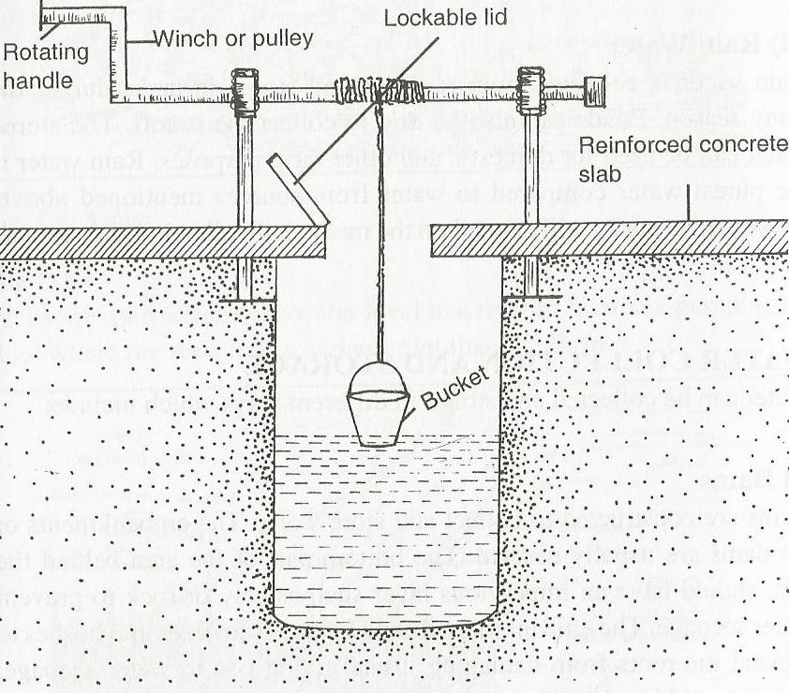
c) Boreholes
These are deep holes drilled or sunk into the ground by use of drilling machines. The holes are usually sunk into the Parent rock to ensure continuous supply of water. The hole is of small diameter and usually lined with metal casing perforated at the bottom end to allow the water to rise up. Special pumps operated by either electricity or engines are used to lift water out of the hole.
3. Rain water
Collected from roofs then stored in tanks. Ponds also constructed to store the run off. This is done during the rainy season.
Water collection and storage
Methods of water collection and storage include:
- Dams
- Weirs
- Water tanks
1. Dams
This is a barrier constructed across a river or dry valley to hold water and raise its level to form a reservoir or lake. It has a spillway to allow excess water flow away. The accumulated water is then pumped to farms.
2. Weirs
A weir is a barrier constructed across the river to raise the water level, but still allow water to flow over it

3. Water tanks
Rain water, ground water and run off can be stored in tanks. The water storage structures (tanks) include:
- Concrete tanks (overhead or underground)
- Corrugated iron sheets
- Steel tanks
- Plastic tanks
Parts of a water tank

- Funnel lid
- Overflow pipe
- Drainage pipe
- Roof
- Gutter
- Outlet
- Base

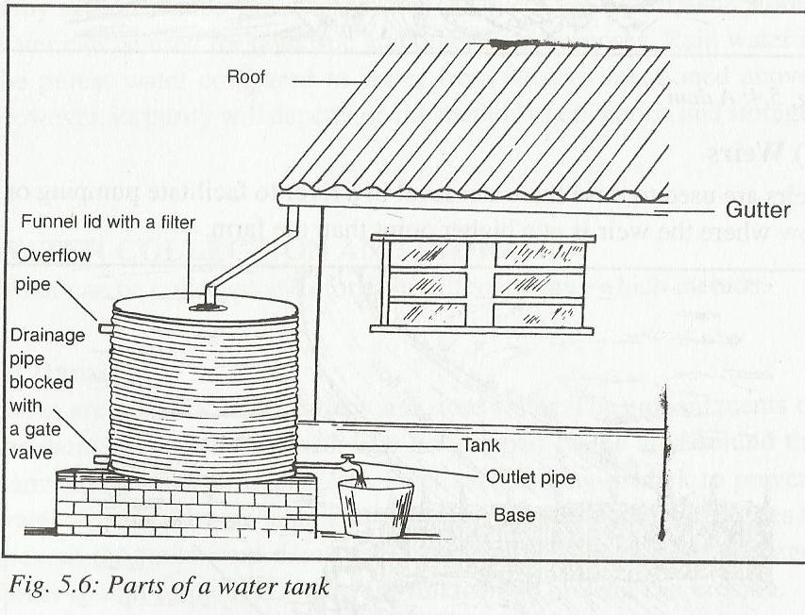
Pumps and pumping of water
1. Water pumps
Types of water pumps include:
- Centrifugal/Rotar dynamic pumps
- Piston/Reciprocating pumps
- Semi rotary pumps
- Hydram pumps
a) Centrifugal pumps: These are made of metal discs with blades that rotate at high speed. They are powerful and can pump water for irrigation. Electric motors, diesel or petrol engines are used to operate them.
b) Piston pumps: Consist of pistons that move back and forth thereby pushing water through the pipes. Do not pump a lot of water thus suitable only for domestic and livestock use.
Have valve to prevent backflow of water
Diagram of a piston pump
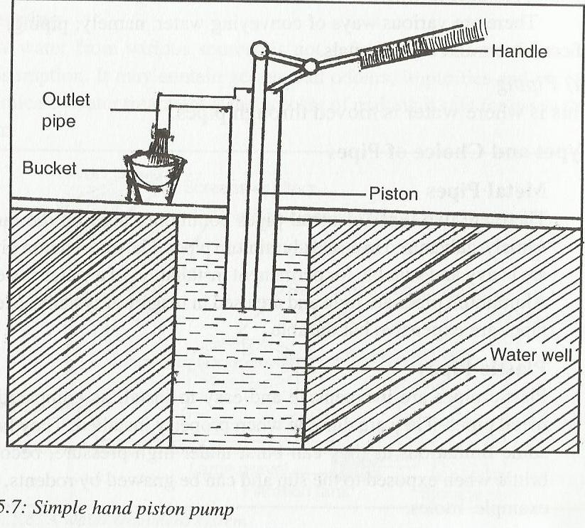
c) Semi rotary pumps
These are operated by hand, and mostly used to pump water from shallow wells for domestic and livestock use
d) Hydram pumps
these are operated by the force of flowing water/ falling by gravity (water fall). The higher the speed of water, the greater the pressure created in the pump.
Cannot pump stationary water and only suitable for slopy areas, where water flows at high speed.
Pumping of water is the lifting of water from one point to another by use of mechanical force.
Conveyance of water
This is the process of moving water from one point to another
Ways of conveying water
- Piping
- Use of containers
- Use of canals
a) Piping
This is where water is moved through pipes
Types of water pipes
i) Metallic pipes
ii) Plastic pipes
iii) Hose pipes
i) Metal pipes
These are two types: Galvanized iron and Aluminum pipes
Galvanized iron pipes are heavy and suitable for permanent installation of water system. Alumimium pipes are light and used for irrigation systems,
N/B: metal pipes are
Expensive
Difficult to join
Some can corrode
Durable
ii) Plastic pipes
These are made of synthetic materials.
Advantages
- They are cheap
- Cannot rust
- Easy to install / join
- Durable when installed properly
- Smooth finish inside offer little resistance to water flow
Disadvantages
- Become brittle when exposed to sun
- Can burst under high pressure
- Can be eaten by rodents
iii) Hose pipes
There are two types: rubber hose pipes and plastic hose pipes
Rubber hose pipes are more expensive but durable, hose pipes are used to convey water from taps to various areas e.g. irrigation areas or washing places
Are flexible and can easily be manipulated to convey water from a fixed point/ taps to required place for irrigation or washing
Choice of pipes
Factors considered when choosing pipes
- Durability – metals last longer
- Strength /thickness of wall / ability to withstand pressure
- Diameter / size
- Colour of pipe
- Workability / manoeuvrability of pipe – hose pipes easy to manipulate
- Availability
- Cost of pipes
- Suitability
b) Use of containers
Water is drawn and put in containers such as drums, jerry cans, pots, tanks and buckets which are carried by animals, bicycles, human beings and vehicles
c) Use of canals
Water is conveyed from a high point to a lower appoint along a gradual slope to avoid soil erosion. Water conveyed in canals is mostly used for irrigation and livestock drinks
WATER TREATMENT
Water treatment is the process of making raw water from source safe for use in the farm.
Importance of treating water
- To kill disease causing micro organisms such as cholera and typhoid bacteria which thrive in dirty water
- To remove chemical impurities such as excess fluoride this may be harmful to humans
- To remove smell and bad taste
- To remove sediments of solid particles
- Make it neutral
- Make it soft which readily form lather with soap

The process of water treatment in a water treatment plant
Involves the following stages;
- Filtration at water intake
- Softening of water
- Coagulation and sedimentation
- Filtration
- Chlorination
- Storage
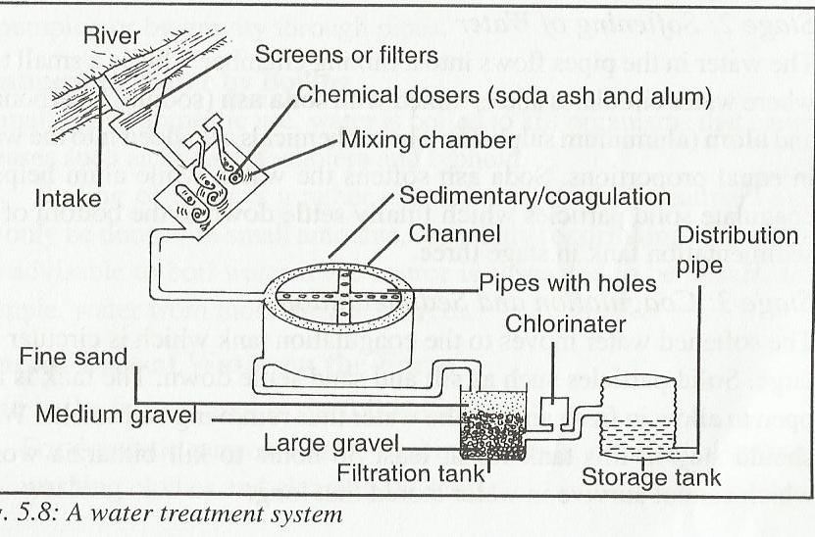
Stage 1: Filtration at water intake
At the point of water intake, water is made to pass through sieves before entering the intake pipe. This is to trap large impurities. Several sieves of different sizes are made.
Stage 2: Softening of water
The water in the pipe flows into the mixing chamber. This is a small tank where water circulates and is mixed with soda ash (Sodium bicarbonate) and alum ( Aluminium sulphate) these chemicals are added into water in equal proportions. Soda ash softens the water, while alum helps to coagulate solid particles which finally settle down to the bottom
Stage 3: Coagulation and sedimentation
The softened water moves to the coagulation tank which is circular where large solid particles such as silt and sand coagulate and settle down. The tank is also open to allow in fresh air into the water. Water should stay in this tank for at least 36 hrs to kill bilharzia worms which cannot survive in water stored that long
Stage 4: Filtration
Water with very few impurities passes into a filtration tank where all the remaining solid particles such as silt are removed. The filtration tank has layers of different sizes of gravel and a top layer of sand. At its bottom is a layer of large pieces of gravel, this is followed by another layer of gravel but of fine texture. A layer of fine sand is placed on top of this fine gravel. These layers allow water to seep through very slowly leaving all the solid particles behind. When water leaves this tank, it’s clean.
Stage 5: Chlorination
The filtered water enters the chlorination tank. In this tank, small amount of chlorine solution is controlled by a dozer and the amount added will depend on the volume of water to be treated and the outbreak of water borne diseases. Chlorine kills pathogens/disease causing microorganisms
Stage 6: storage
Water is then stored in large tanks, before distribution to consumers.
Storage tank should be fenced off to protect water contamination
Water is then distributed to consumers by pumping and piping
General uses of water in the farm
- For domestic purposes e.g. washing, cooking etc
- For watering livestock e.g. washing pigs
- For diluting chemicals
- For processing farm produce e.g. coffee etc
- For construction of buildings
- For irrigation
IRRIGATION
Irrigation is the artificial application of water to soil for the purpose of supplying sufficient moisture to crops.
Conditions that make it necessary for irrigation
- In dry areas/arid areas
- During dry periods
- In the growing of paddy rice
- Soften the soil during transplanting
- To effect the application of fertilizers and other chemicals
Factors that determine the type of irrigation to use
- Capital availability
- Topography of the land
- Water availability/amount of water available
- Type of soil
- Type of crop to be irrigated
Types of irrigation
- Surface irrigation
- Sub surface irrigation
- Overhead irrigation
- Drip/Trickle irrigation
1. Surface irrigation
Here water is applied to the field by allowing it to flow on top of the ground surface/canals /furrows
Methods of surface irrigation
- Flood irrigation
- Furrow irrigation
- Basin irrigation
- Boarder irrigation
a) Flood irrigation
Water is allowed to cover the whole field a few centimeters in depth. It’s suitable for growing paddy rice.
Advantages of flood irrigation
- It’s cheap to establish and maintain
- Require less skills
Disadvantages of flood irrigation
- There is uneven distribution of water in the field
- A lot of water is wasted
- Needs plenty of water
- Siltation of canals is common
b) Furrow irrigation
Here water is supplied by use of open ditches or furrows. It’s suitable for all crops and application to most soils
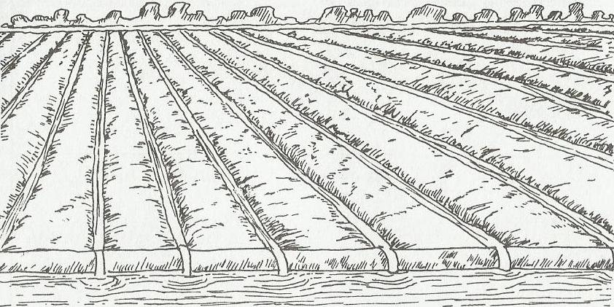
Maintenance of furrows
- Repair furrows when worn out or eroded
- Remove weeds and silts
Advantages of furrow irrigation
- Reduces chances of fungal diseases
- Cheap to establish
- Require little skills
Disadvantages of furrow irrigation
- A lot of water is lost through evaporation and seepage
- Erosion can occur if the furrows are not maintained
- If water has high content of salt, it may have damaging effect on the plant roots
c) Basin irrigation
Basin irrigation involves the application of water into basins that have been checked by construction of banks or ridges. The basins may be rectangular ring shaped or have contour checks
This system is suitable in:
- Relatively flat areas
- Soils of low infiltration
- For crops requiring large quantities of water
- Soils that require leaching
Advantages of basin irrigation
- Helps to control soil erosion
- Retains rain water in the basins
- Does not require a lot of skills
Disadvantages of basin irrigation
- Much land is occupied by water covering channels and ridges
- There is no surface drainage
- Requires precise land grading
- Requires a lot of labour
- Cannot be used in crops that require free draining soils
- May result in accumulation of salts
N/B-Areas where basin irrigation is being practiced in kenya: Mwea tebere, Ahero, Bunyala, west kano etc
d) Boarder irrigation
This is where parallel ridges guide a sheet of water that spread and cover a relatively flat, but slanting piece of land. The ridges form long boarders. This method is applied where:
- Soils have low to relatively high infiltration capacity
- Crops are closely spaced, such as wheat, barley fodder crops as well as legumes
Advantages of boarder irrigation
- It is easy and simple to operate
- Requires less labour as compared to basin irrigation
- Boarder ridges can be constructed economically with simple farm implements eg ox drawn ridgers
- Large irrigation streams can be efficiently used
2. Sub surface irrigation
This is a system of irrigation where water is supplied to crops using underground perforated pipelines or any other porous medium that make water available from below the soil surface. Pipes sometimes referred to as conduits
The system is suitable in soils of high capillarity and water holding capacity
Advantages of sub surface irrigation
- Little labour requirements
- No need to construct dykes or soil grading
- Can be practiced on both sloppy and flat land
- Water does not cause soil erosion
- Does not encourage fungal diseases
- Economizes use of water
- Minimizes theft of pipes
- Soluble fertilizers can be applied together with irrigation water
Disadvantages of sub surface irrigation
- It’s expensive method i.e. to buy pipes and to lay them
- Pipes can be broken during weeding
- Nozzles can get blocked
3. Overhead irrigation
This is the application of water above the crops by means of sprinklers or watering cans. Wind breaks should be constructed to avoid misdirecting the water.
Types of sprinklers
- The continuous rotating sprinkler –suitable for small scale
- The spring loaded sprinkler –suitable for large scale irrigation
Advantages of overhead irrigation
- Water is evenly distributed over the required area
- There is less water wastage than in furrow irrigation
- It can be practiced on slopy grounds
- Foliar fertilizers can be applied together with irrigation water thus reducing labour costs
- Sprinkler systems can be easily be moved from one place to another
Disadvantages of overhead irrigation
- It’s expensive to install
- Encourages fungal diseases e.g. blight, CBD
- Causes soil erosion
- Requires establishment of wind breaks
Sprinklers used are: oscillatory sprinklers, spring loaded sprinklers
Sprinklers can also be classified into: rotating head, perforated pipe system
Maintenance of sprinklers and pipes
- Lubricate the rotating parts
- Repair broken parts
- Cleaning and unblock the nozzles
4. Drip/Trickle irrigation
Here pipes with tiny perforations are used. As water passes through the plastic pipes, water comes out through the holes in small amounts and drips to the ground.
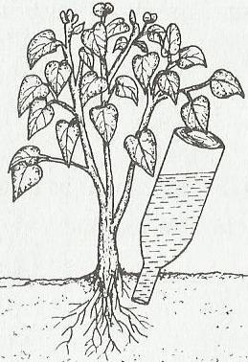
Advantages of drip irrigation
- Requires little amount of water
- Can also use water of low pressure
- Discourages fungal diseases e.g. blight, CBD
- Does not encourage the growth of weeds
- Can be used in sloppy topography
Disadvantages of drip irrigation
- Pipes are expensive to buy and install
- Require clean water, since dirty water will block the perforations
- Requires high technical knowhow to install and to maintain
Factors to consider when choosing irrigation equipment
- Capital availability
- Topography
- Availability of repair and maintenance
- Type and source of power
- Source of water
DRAINAGE
This is the method of removing excess water from water logged land to make it suitable for agricultural production
It’s a method of land reclamation.
Land reclamation is the process of bringing back waste land to agricultural production
Importance of drainage
- Improves soil aeration: removal of excess water around the root zone allows for enough air for proper growth
- Increases soil volume: increases the amount of soil around the roots
- To raise the soil temperature: improves the rate at which soil warms up for better plant growth
- Increases microbial activities: micro organisms in the soil increase in number due to proper aeration, they help to improve soil structure and make plant food more readily available
- Reduce soil erosion: well drained soils have higher water holding capacity which helps to reduce water runoff and increase infiltration
- Remove toxic substances: due to water logging, soluble salts such as those of sodium increases in concentration to levels that are toxic to plants or may retard growth
- Remove water that may be interfering with farming operations
- Reduces incidences of water borne pests and diseases e.g. bilhazia ,malaria
Methods of drainage
- Use of open ditches
- Underground drain pipes
- French drains
- Cambered beds
- Pumping out of water
- Planting trees
a) Use of open ditches:
- Ditches are dug for the water to flow in by gravity to a water way thereby lowering the water table. May be U shaped or V shaped or trapezoidal
Advantages
- Cheap to use
- Large quantities of water can be easily drained
Disadvantages
- High maintenance cost
- Soil erosion may arise
- Take off valuable land space which could have been used
- Interfere with agricultural mechanization of certain operations
b) Underground drain pipes:
Perforated pipes are laid underground. Water then seeps from the surrounding area into the pipes and flows to a water away. Such drains do not interfere with field operations. The pipes may be made of steel, clay or plastic materials
Advantages
- Does not interfere with farm operations
c) French drains:
- Ditches are dug, filled with stones and gravel, and then covered with soil. Water from the surrounding area seeps into these drains and is carried into a water way
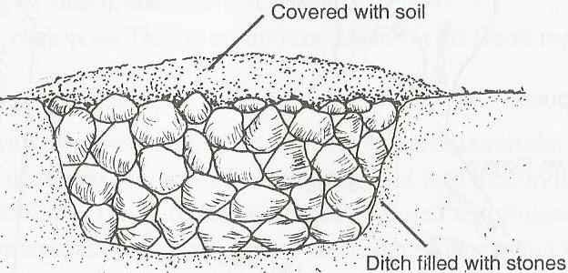
d) Cambered beds:
Raised beds are constructed on the poorly drained soils
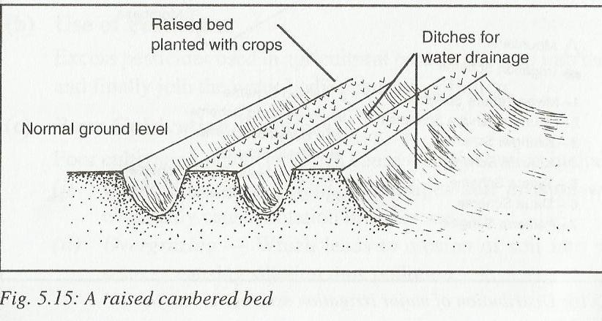
Pumping: where other methods of drainage are not possible, water is pumped out.
Areas where drainage has been carried out in kenya are: yala and bunyala to control flooding, ahero to control flooding of river nyando, loriaan region

WATER POLLUTION
This is the contamination of water by either chemical, industrial wastes, farm residues etc, making it unsafe for human beings and animals.
Agricultural practices that pollute water
- Fertilizer and pesticides: chemicals compound found in the fertilizers and other pesticides do not decompose easily, hence they find their way into water sources through drainage, irrigation channels, erosion, seepage and leaching
- Improper disposal of used farm chemicals: when containers contaminated with chemicals are disposed of into water sources, the result is water pollution
- Damping of farm wastes: farm wastes such as slurry, manure used polythene, dead animals etc when improperly disposed of cause water pollution.
- When land is cultivated or the soil is left bare erosion will easily occur leading to contamination through unwanted soil
- Blockage of irrigation channels and water ways prevents free flow of water leading to stagnation of contaminated water
- When pit latrines and sewage sites are located near water sources, they cause pollution
- Other sources of pollution include industrial wastes and generalized contamination in the atmosphere and the environment
Methods of preventing water pollution
- Practice organic farming
- Safe disposal of used farm chemicals and industrial wastes
- Proper location of pit latrines, sewage sites and waste dumps
- Control of irrigation and establishment of grassed water ways to purify the water
- Controlled use of fertilizers, manures and farm chemicals
- Ensuring that the water source is free from contamination from the farm
- Treating and piping water for farm use

